My Machine

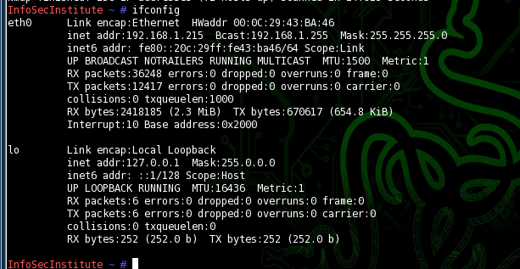

Open FTP Servers-using trial and error

192.168.1.3

192.168.1.99

\*192.168.1.127

192.168.1.128

192.168.1.254

Using metasploit

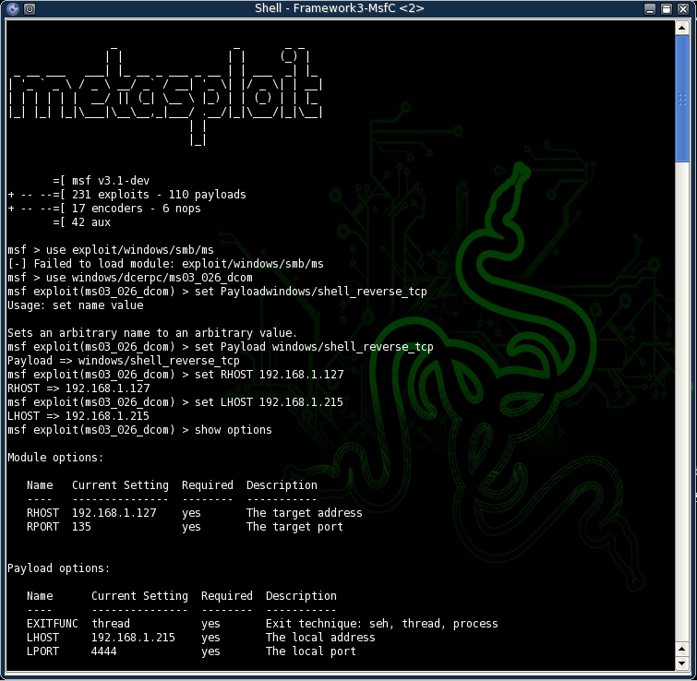

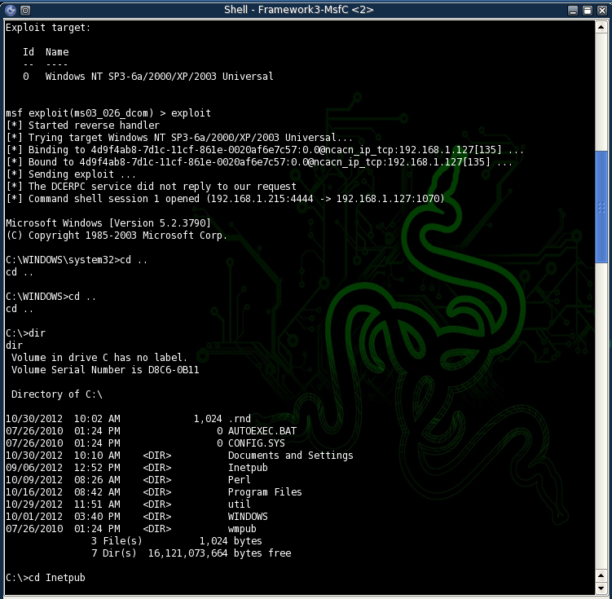

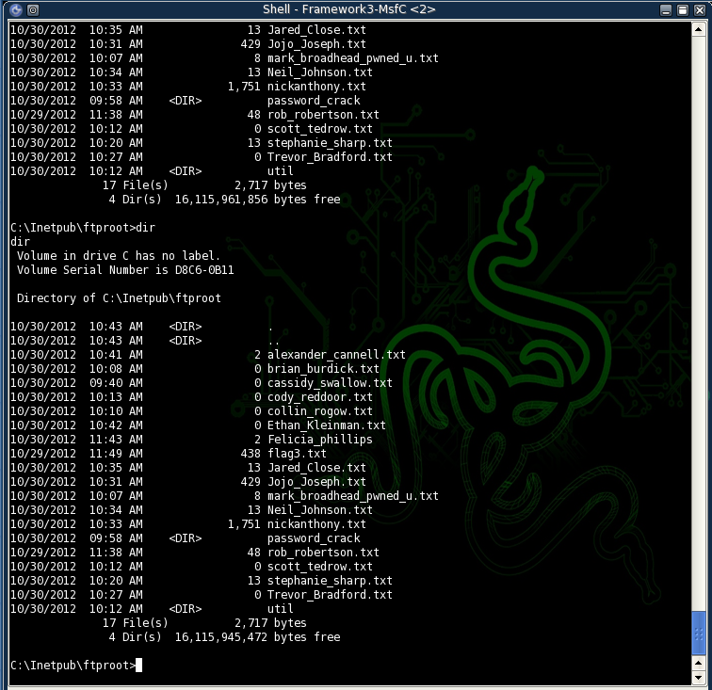

Type flag3.txt shows the text in the file so I viewed the text opened a text document and copied the hash to a file

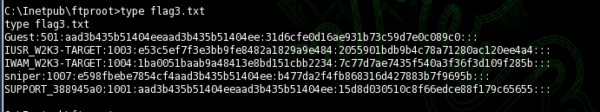

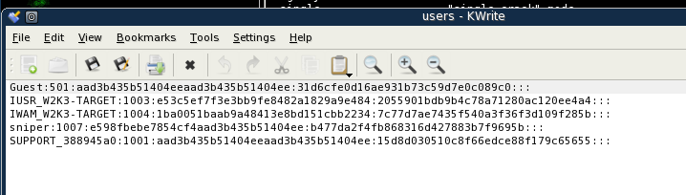

Using John the ripper the password is ZEBRA

